Collaboration at Sea II
Web Site Administration Guide



CAS II Web Admin Guide

Version 1
November 2007
Table of Contents

1.0 CAS II Web Site 4

1.1 Header 5

1.2 Home Menu 5

1.3 Sub-home Menu 5

1.4 Content Area 5

1.5 Footer 5

1.6 CAS II Web Site Administrator Privileges 5

2.0 Header 6

2.1 Authentication (Login/Logout) 6

2.2 Header Administration 6

2.3 Header Access 6

2.4 Header Setup 8
2.4.1 Website Title 8 2.4.2 Description 8
24.3 Background color 9
24.4 Logo Edit 9
24.5 Corner Images 9
24.6 News URL and News Dimensions 9
24.7 Accelerators 10
2.4.7.1 Recent Posts 10
2.4.7.2 New Document and Browse 11
2.4.7.3 Functional Areas 11
2.4.7.4 Class and Release 13
2.4.7.5 Header completion and viewing 13
2.5 News 14
2.5.1 News Title 14
2.5.2 News 14
2.5.3 Auto Refresh 14
2.5.4 Text Format 14
2.5.5 News Classification and Release 15
2.5.6 Saving the News 15

2.6 Conditions Chart 16
2.6.1 Condition Configuration 17
2.6.2 Add a Condition 17
2.6.3 Edit an existing Condition 17
2.6.3.1 Edit an existing Condition’s Status 19 2.6.3.2 Add a Condition Status 19

3.0 Document Libraries 20

3.1 Document Library Design 20

3.2 CAS II Site Links 22
3.2.1 The Link Icon 22
3.2.2 Relative links 22
3.2.3 Absolute Links 23
3.2.4 Copying Links 23
3.2.5 Pasting Links 23

4.0 Menu Management 25

4.1 CREATE a New Menu 25

4.2 EDIT an Existing Menu 26

4.3 Home and Sub-home Menu Management 27

4.4 View a Menu 27

5.0 Link a Sub-home Menu to a Home Menu Item 28

5.1 Configure a Home Menu Item with a Sub-home Menu 28

5.2 Link a Sub-home Menu/Home Menu Item Using Java 29

6.0 Footer (Clocks) Management 30

6.1 Add a Clock 30

6.2 Edit a Clock 31

7.0 Content Area Management 32

7.1 Create Bullet Lists 33

7.2 Edit or Delete Bullet Lists 34
7.2.1 Edit Defaults 34
7.2.2 Delete Listing 35
7.2.3 Clone Listing 35
7.2.4 Reorder Items 35
7.2.5 Preview Listing 35
7.2.6 Edit or Delete an Individual Bullet item 36
7.2.7 Create a New Bullet Item 37

7.3 Create a Display Page 38

7.4 Edit or Delete a Display Page 39

7.5 Personalizing Display Pages using HTML 40

8.0 Framesets 43

8.1 Frameset Generator 44
8.1.1 Home 44
8.1.2 New Frameset 44
8.1.3 Frameset Listing 44

8.2 Create a Frameset 45

8.3 Edit or Delete a Frameset 48

8.4 Clone a Frameset 49

8.5 Cloning Multiple Sites 50

9.0 Style (Style Sheets) 51

10.0 Generating Multiple Sites 52

- CAS II Web Site
- Figure (1.0) is an example of a default CAS II Web Site.

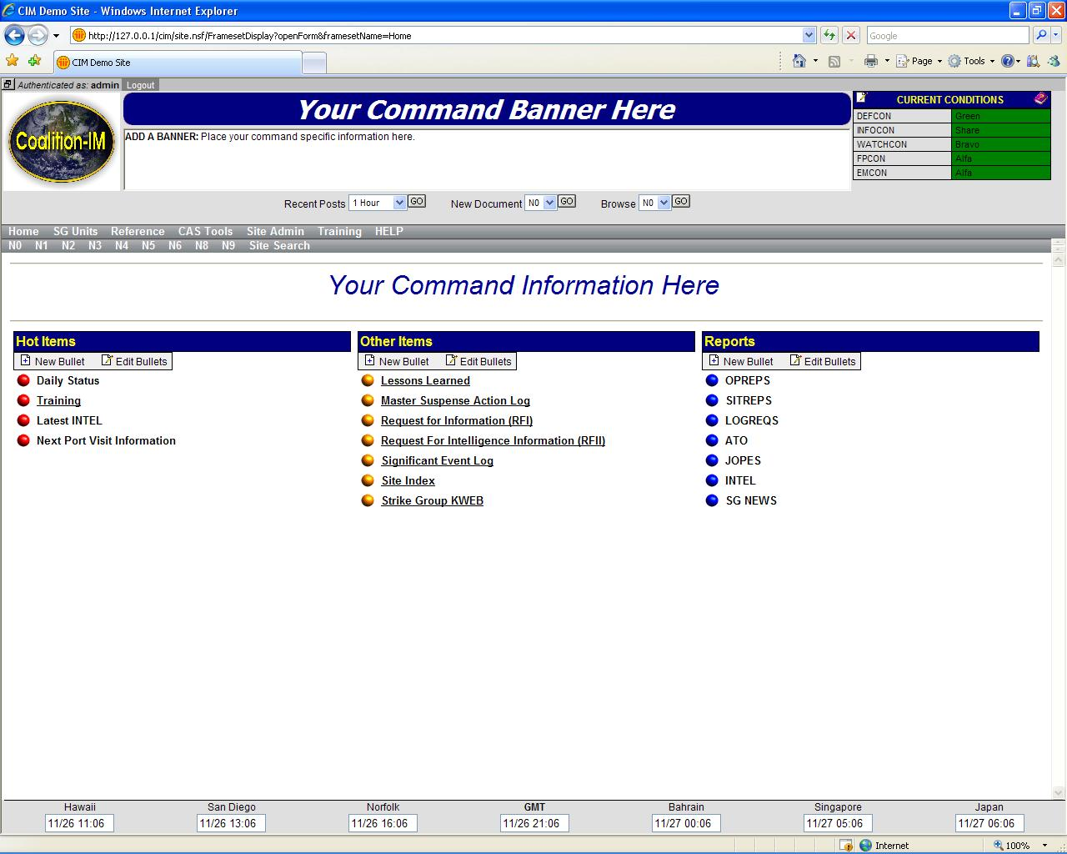
(Figure 1.0)

